VDR 3 Prototype

Department of Mechanical Engineering, FSU-FAMU

Team: 509
Jack Corbin, Prosley Dorcely, Emily Groth, Deepkumar Patel, Aaron Weingarten

Course:
EML 4551C

Professor:
Dr. McConomy

Date:
November 29th, 2022

Smart Projectile
Concerning the current state of our selected design, we are using last years’ Solidworks files to determine which parts are reusable and which parts need to be purchased or machined. For the nose actuation, we have identified a few parts which are reusable. Using last year's parts will help improve the overall cost of the project. However, the fin deflection must be designed as there were no fins on the previous model. For the nose actuation, our design is integrated with two stepper motors which will be placed in the middle portion of the projectile to control the nose cone's movement. For the fins, we are using four servo motors placed in the middle of each fin to control the deflection to 30 degrees. As for the material, we have decided to use aluminum. With these components added, we will have drastically improved the design mechanism since last year.
For our future work, we are going to reduce the deflection of the nose cone up to 5 degrees. Additionally, we are going to reduce the weight of the nose cone by hollowing out portions of the nose cone which are not required. To get the complex geometries needed for significant weight reduction we are planning on using additive manufacturing in the form of aluminum sintering. At the same time, we need to create a mechanism to control the fins independently using the servo motors. Between the nose cone and fins, we are going to be working on the skin to maintain flow attachments. The skin should be at least 2 diameters long.
We are then going to create CAD model and Arduino code for our project which will be used for prototyping. In our prototyping stage, controls for both the fins and the nose cone will be developed and tested; the testing of the controls will allow us to optimize the controls and improve the parameters so that the cone can fulfill the design requirements. After the prototyping is done, we will move into the machining and assembly of our projectile for final testing and optimization before the senior design day.
Regarding the problem areas that we have identified with our project, the biggest that comes to mind deals with the deflectable fins that will be added towards the back of our model. Our first problem with the fins is to determine how they will be attached to the model and powered. We have decided that the powering of the fins will be done by a servo motor. We must select the servo motor that gives us enough torque as well as the one that will fit into the constraints of the design of our model. This will be challenging because we want to have four different servo motors for each one of our deflectable fins. Additionally, the base of the fins is small, making it challenging to mount it to the motor using a shaft. The other problem we could struggle with is the code for controlling the articulating nose cone. Last year's design team had trouble with a non-linear motion so correcting this will be difficult. However, because we have decreased our angle of deflection from twenty degrees to five degrees, it should help with the nose cone’s linear motion.
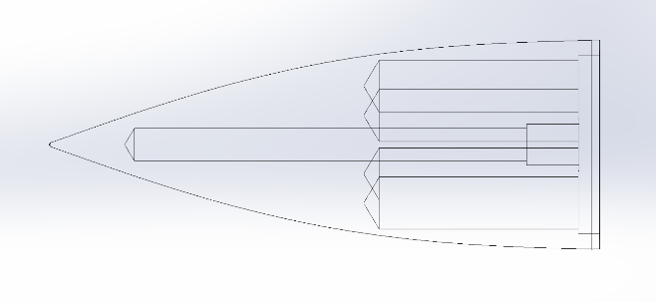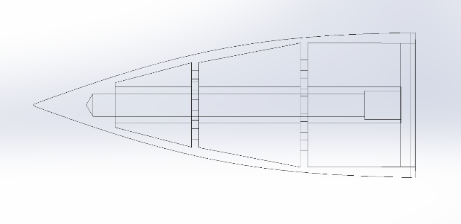
Previous nose cone: 269g (0.59 lbs) First attempt at light weighting: 138g (0.31 lbs)

